**PRACTICAL-1**

**AIM:**

Demonstrate the simple network configuration with a router that connects two local area network (LAN) segments using cisco packet tracer.

**THEORY:**

**ROUTER:**

* A router is a networking device that forwards data packets between computer networks.
* The router is mainly a Network Layer device.
* Routers normally connect LANs and WANs together and have a dynamically updating routing table based on which they make decisions on routing the data packets
* Major Functions of Router are FORWARDING and ROUTING.
* When a data packet comes in on one of the lines, the router reads the [network address](https://en.wikipedia.org/wiki/Network_address) information in the packet header to determine the ultimate destination. Then, using information in its [routing table](https://en.wikipedia.org/wiki/Routing_table) or [routing policy](https://en.wikipedia.org/wiki/Routing_policy), it directs the packet to the next network on its journey

**LAN:**

* LAN refers to LOCAL AREA NETWORK
* A local area network (LAN) is a collection of devices connected together in one physical location.
* A LAN comprises cables, access points, switches, routers, and other components that enable devices to connect to internal servers, web servers, and other LANs via wide area networks

**PRACTICAL IMPLEMENTATION:**

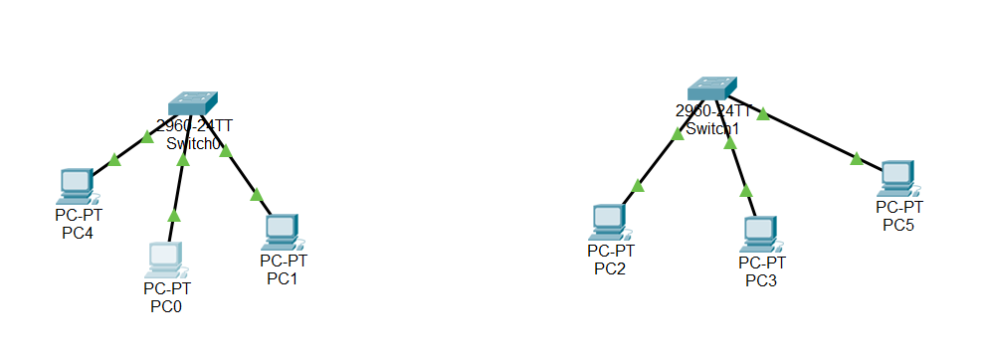

* As seen the picture, we have two separate networks.
* We will connect both the network via router.

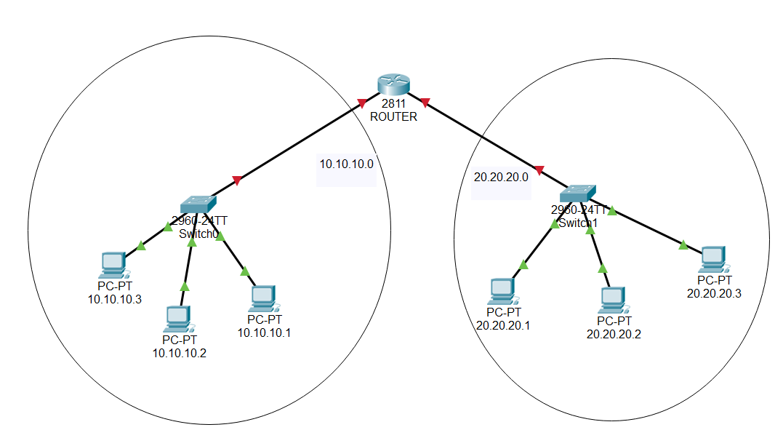

* As seen in the picture, we have physically connected the LANs but still network connection is not established.
* We need to logically connect the two networks
* So, first we will assign IP address to all the PCs.

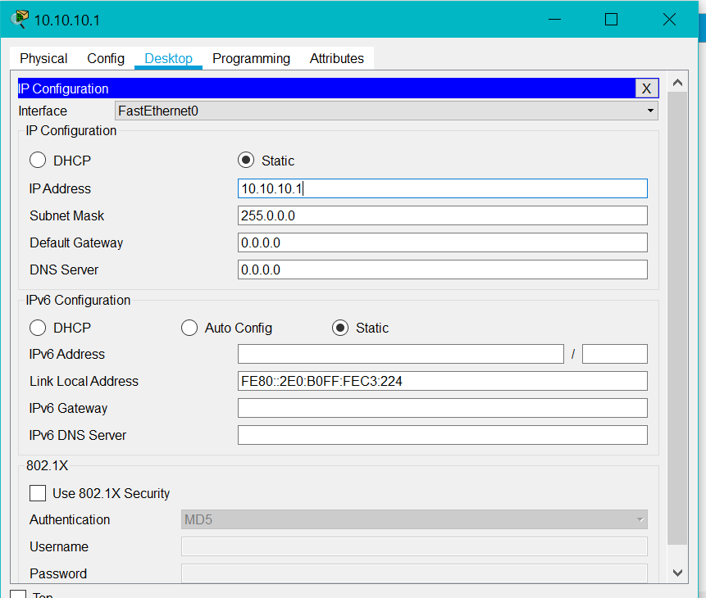

* As seen in the picture, IP address is assigned to PC-1.
* To assign IP address to PC, click on the pc.
* Go to Desktop and click on IP Configuration
* Then, Assign the IP address.
* Perform the same steps for other PCs.
* Now, we will configure the router.

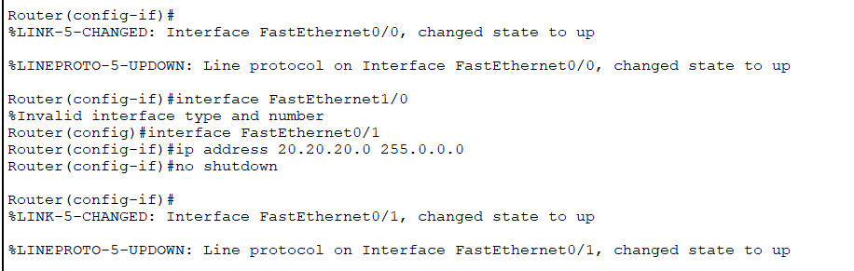

* To configure the router perform the following steps:

1. Press **RETURN**to start the session  
2. Type **enable**to get to *privileged mode*   
3. Type **config terminal** to access the configuration menu.  
4. Type **interface fastethernet0/0** to access Ethernet0/0  
5. Type**ip address xxx.xxx yy.y.yy** to assign an IP address and [subnet mask](http://learn-networking.com/network-design/how-to-subnet-a-network) to the interface.  
6. Type **no shutdown**to open the interface up for business.

* Perform the same steps for other network.

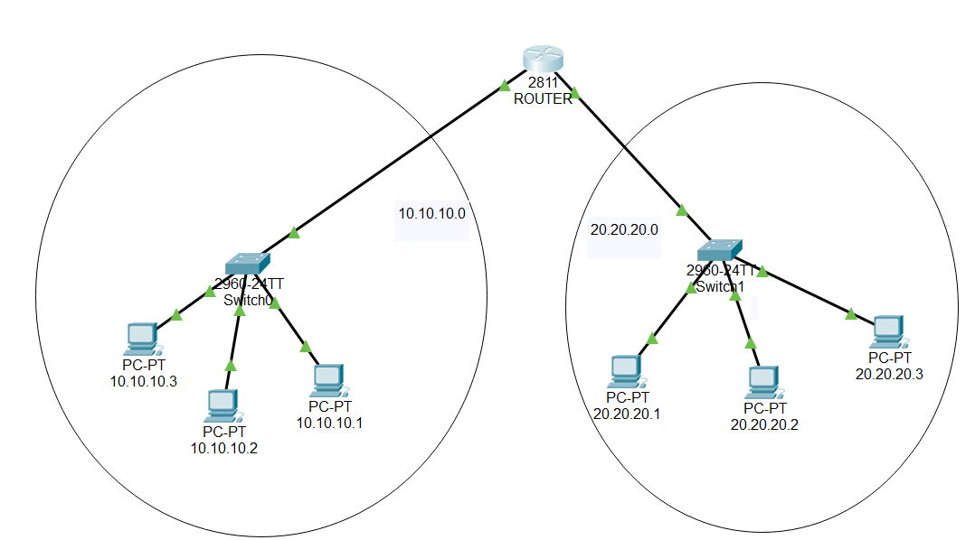

* Now, we need to update default Gateway in every PC so that they can communicate to other LAN.
* To do so, click on PC, go to Desktop, click on IP configuration and update the default gateway with the IP address of the connected router.

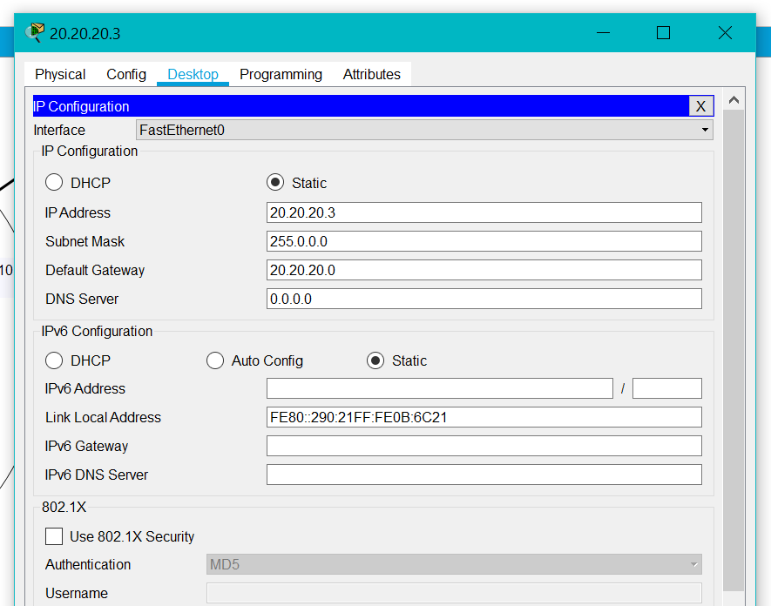

**NETWORK WORKING TEST:**

To test the working of the network topology, we will perform two tests:

1. **We will send packet from one PC of LAN-1 to one PC of LAN-2:**

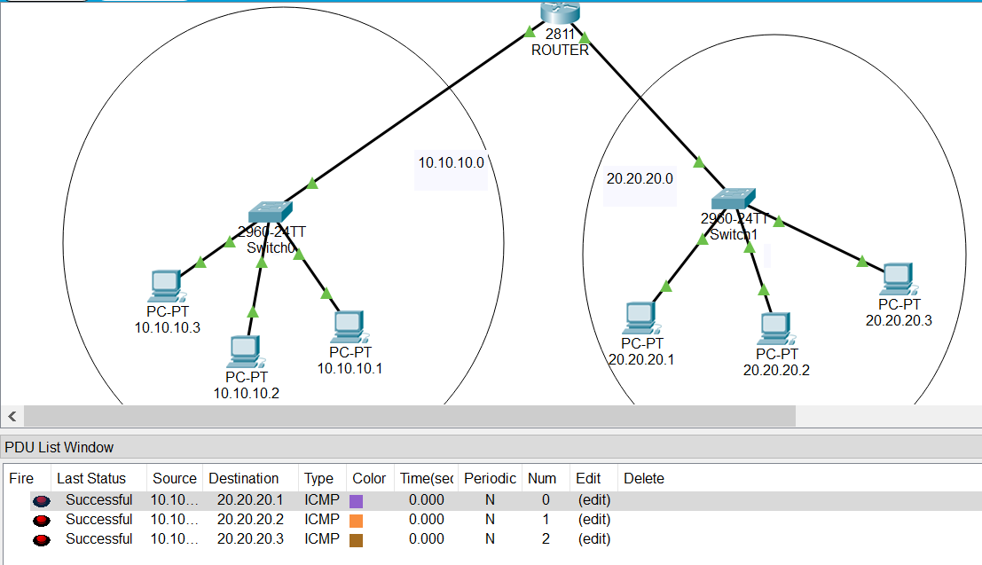

1. **PING Test:**

* We will open command prompt in PC-1 of LAN-1 and will ping PC-2 of LAN-2.
* If the connection is proper, then Reply will be successful.

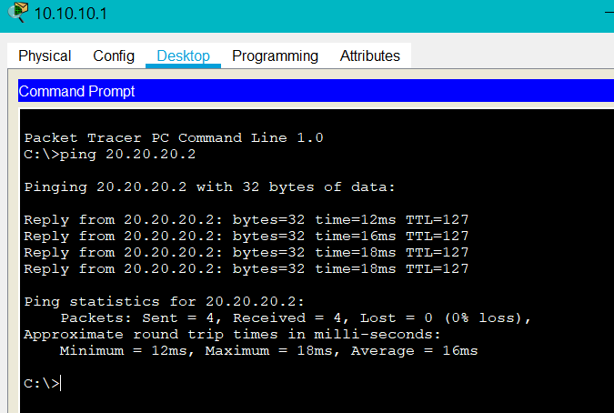

**CONCLUSION:**

By performing the above practical, I learnt about router and it’s working. I also learnt about LAN and how to connect two LANs via router to form a network topology and how to communicate between the networks.